Name : K Jahnavi
Reg no: 192512169
Ex No 7 : Analog Beamforming Analysis Using MATLAB

Aim: To analyze the performance of analog beamforming by studying beamforming gain, beam width, and main lobe direction using MATLAB.
Objectives :
1. To analyze the beamforming gain achieved by varying the number of antenna elements in an analog beamforming system using MATLAB.
2. To compare the beam width of an antenna array for different beamforming configurations using MATLAB.
3. To analyze the main lobe direction by steering the antenna array beam to different angles using MATLAB.
Procedure:
clc;
clear;
close all;
antennas = [2 4 8 16 32]; % Number of Antenna Elements
gain = 10*log10(antennas); % Beamforming Gain (dB)
figure
bar(antennas, gain, "magenta")
grid on
xlabel('Number of Antenna Elements')
ylabel('Beamforming Gain (dB)')
title('192512216 Beamforming Gain for Different Antenna Array Sizes')

Output:
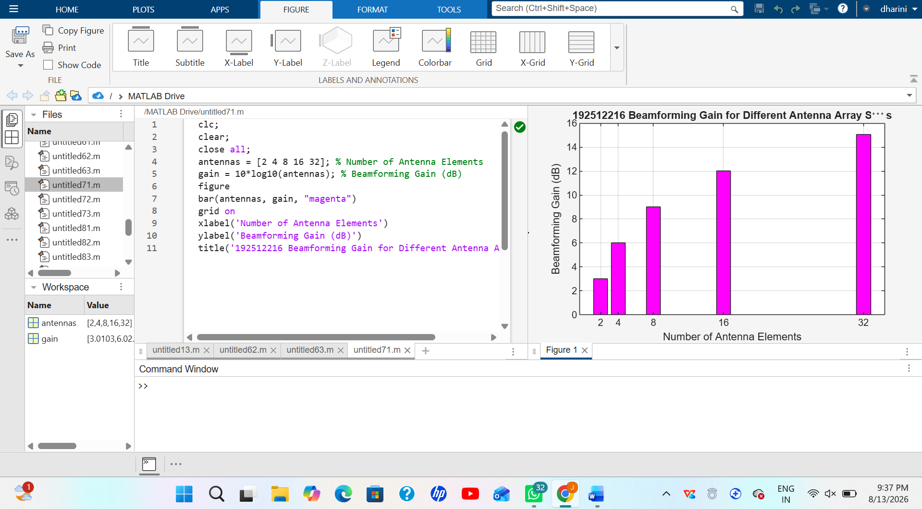
Objective 2:
clc;
clear;
close all;
antennas = [2 4 8 16 32]; % Number of Antenna Elements
beamwidth = [90 45 22.5 11.25 5.625]; % Beam Width (degrees)
figure
plot(antennas, beamwidth,'o-','LineWidth',2, 'Color', 'r')
grid on
xlabel('Number of Antenna Elements')
ylabel('Beam Width (Degrees)')
title('192512216 Beam Width for Different Antenna Array Sizes')

output :
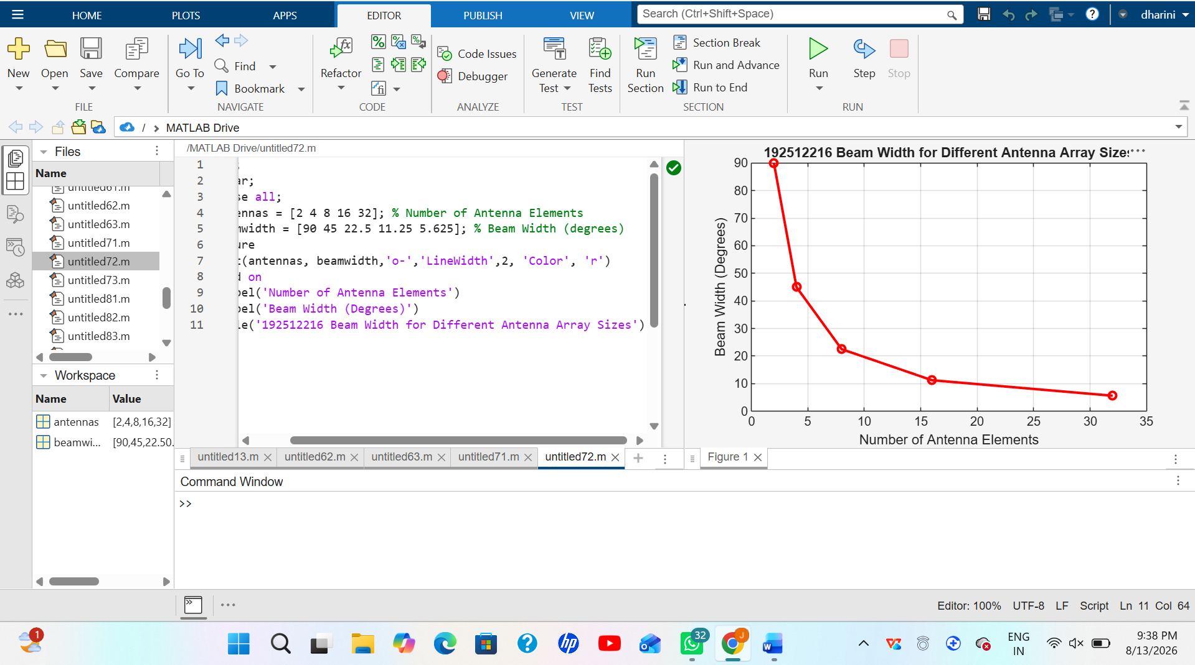
Objective 3:
clc;
clear;
close all;
theta = [-60 -30 0 30 60]; % Main Lobe Direction (degrees)
gain = [1 1 1 1 1]; % Constant normalized gain
figure
polarplot(deg2rad(theta), gain, 'o', 'LineWidth', 2,'Color','g')
title('Main Lobe Direction in Analog Beamforming')

output :
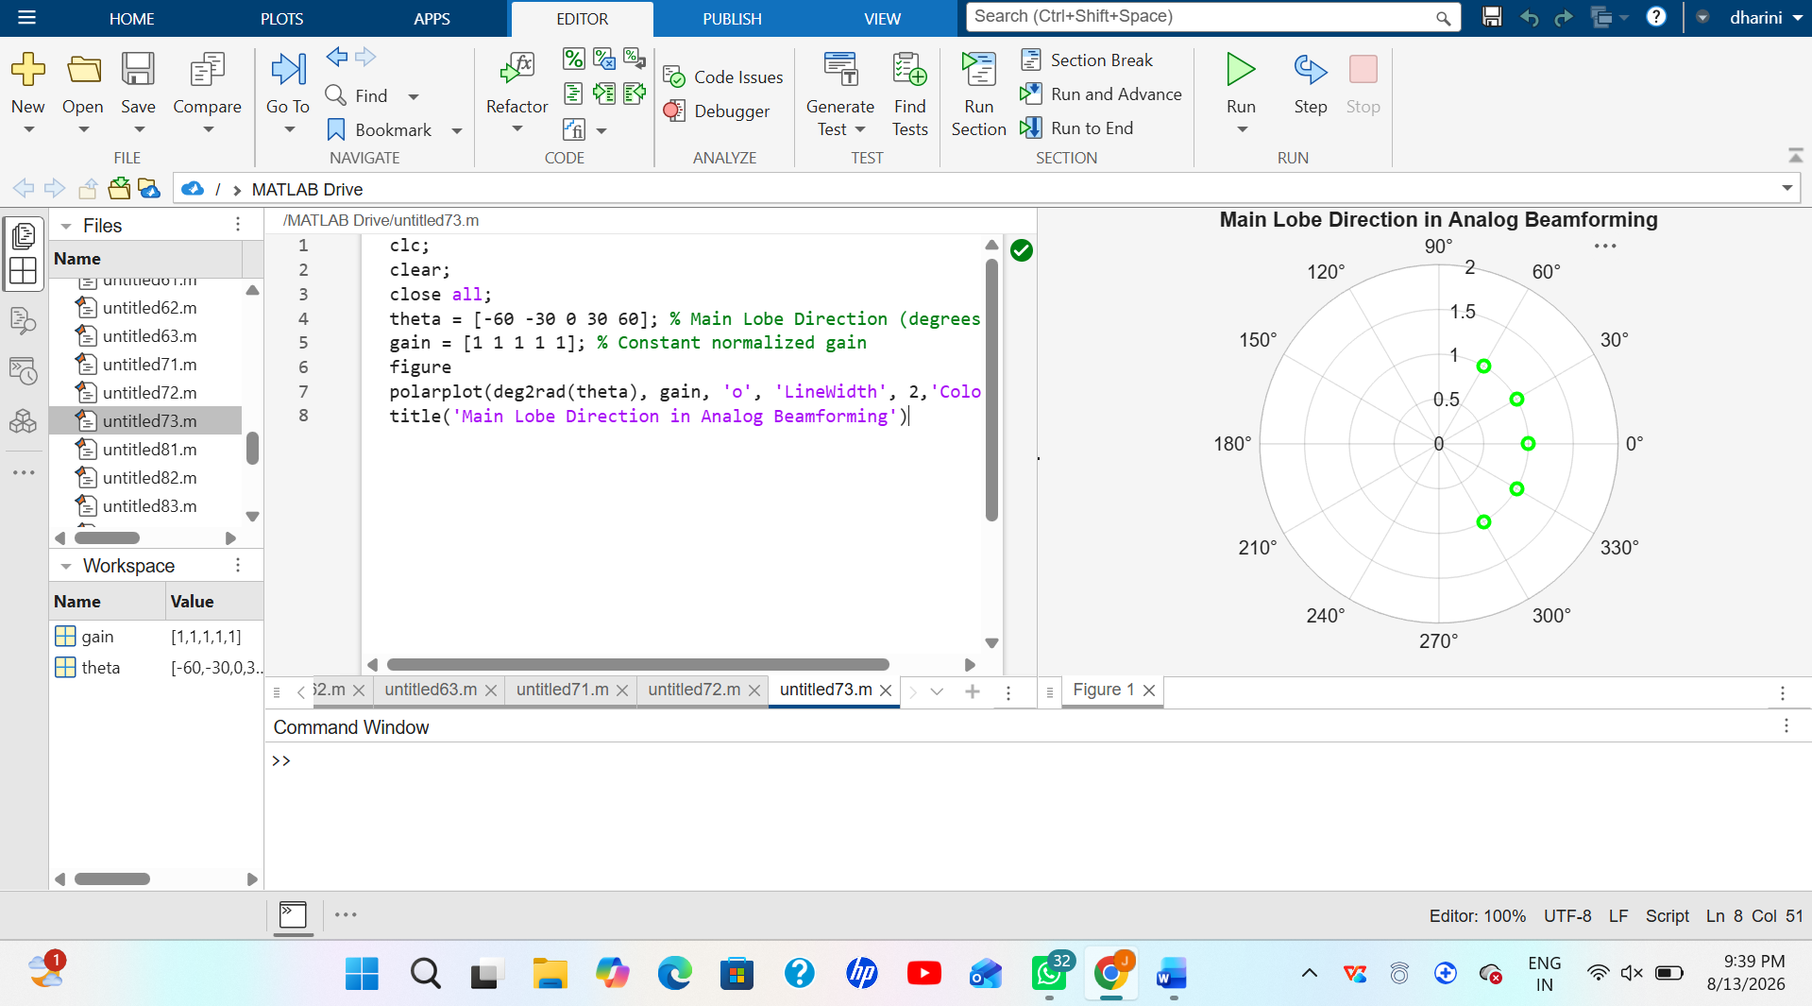
Result
The MATLAB analysis successfully demonstrated the characteristics of analog beamforming. The results showed that increasing the number of antenna elements improves beamforming gain and reduces beam width, while phase adjustment enables the main lobe to be steered toward different directions.

